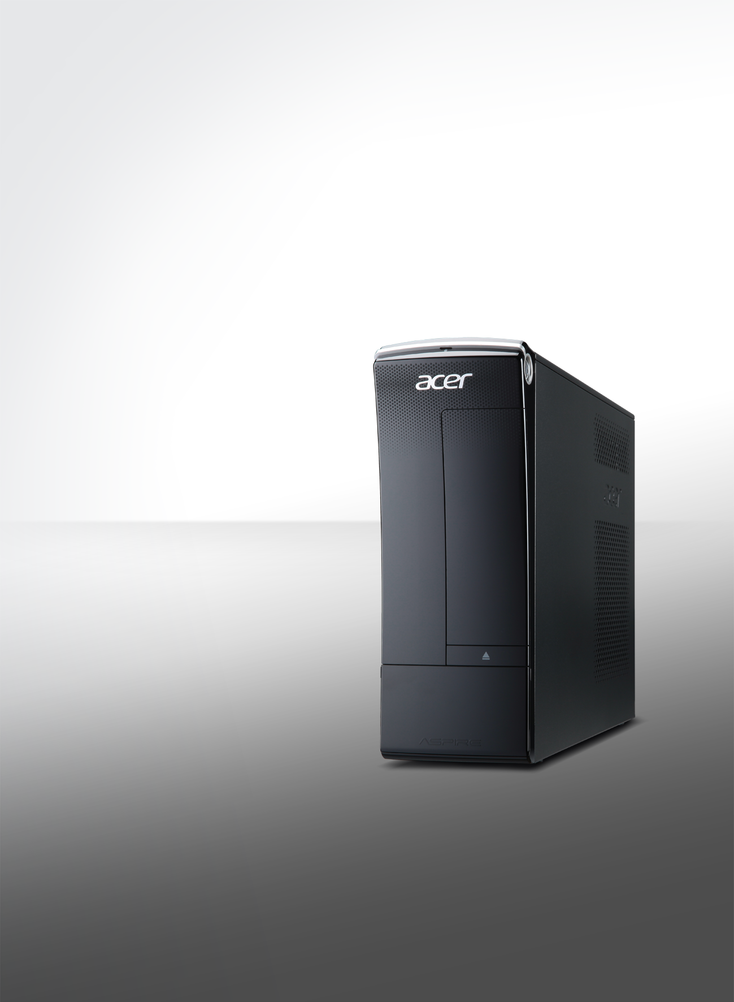

Windows®. Life without Walls™. Acer recommends Windows 7.
X3470

- Efficient multitasking
- Rich HD experiences
- Easy expandability
- Modern, practical design

Serious graphics warriors
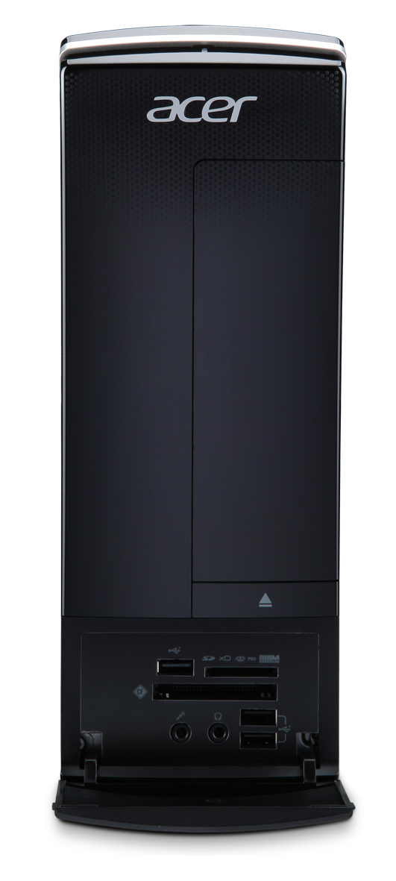
 | 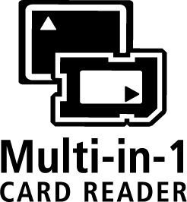 |  |  |  |  |  | 

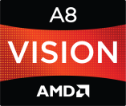 | 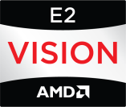 | 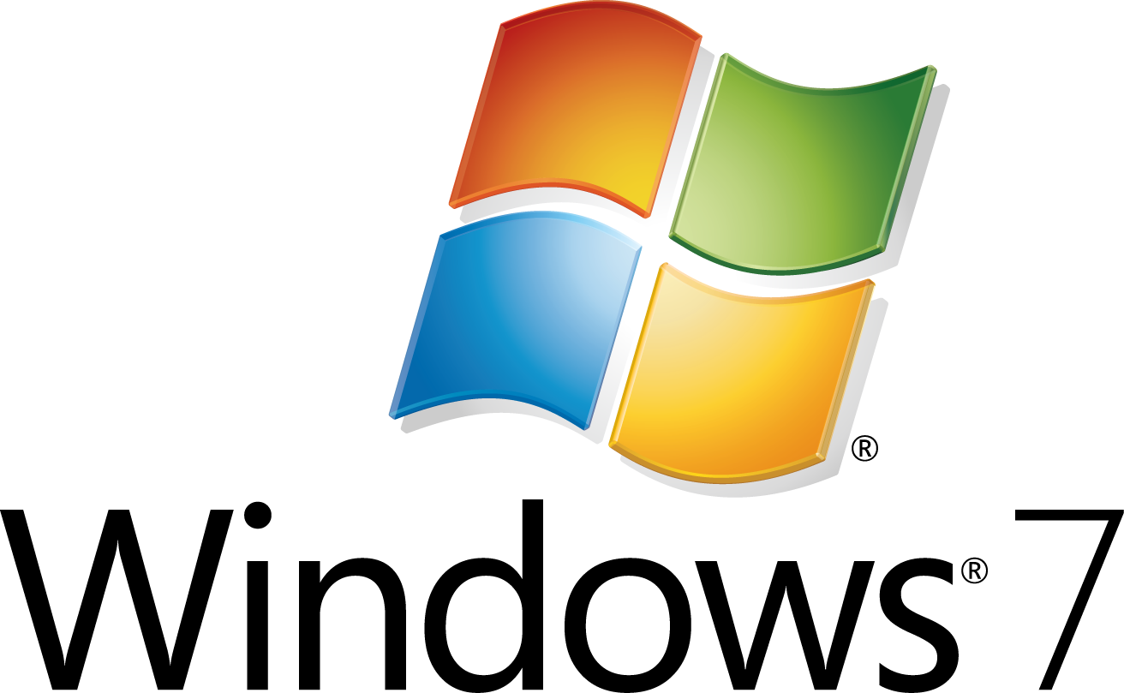 |  |  | 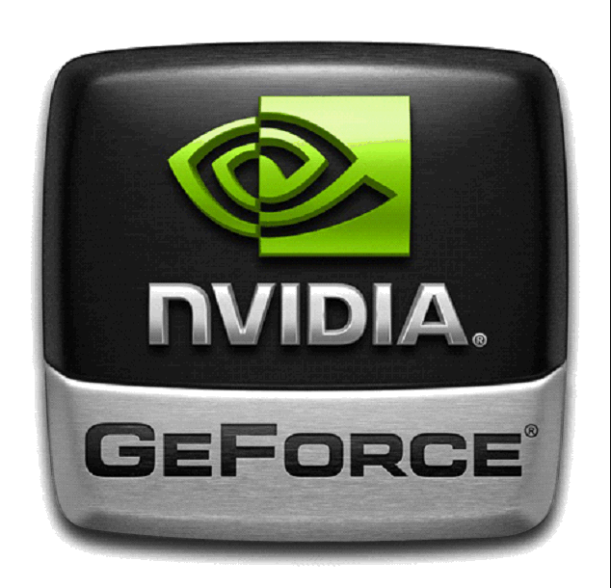 |  | 

Windows®. Life without Walls™. Acer recommends Windows 7.

Aspire X3470 | SPECIFICATIONS
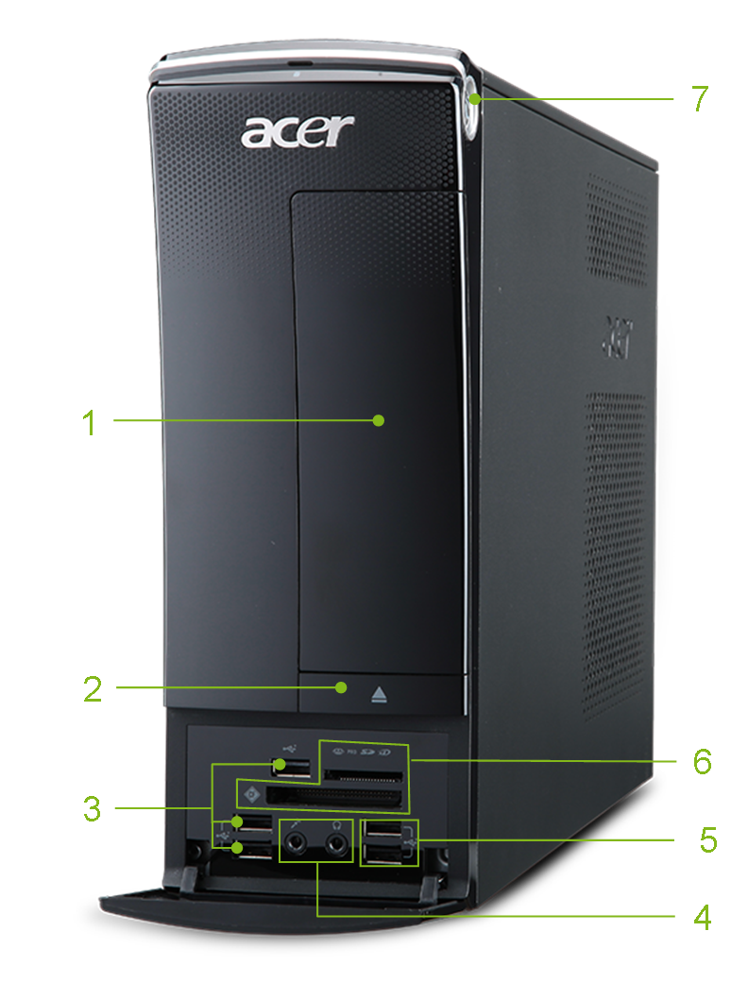 | 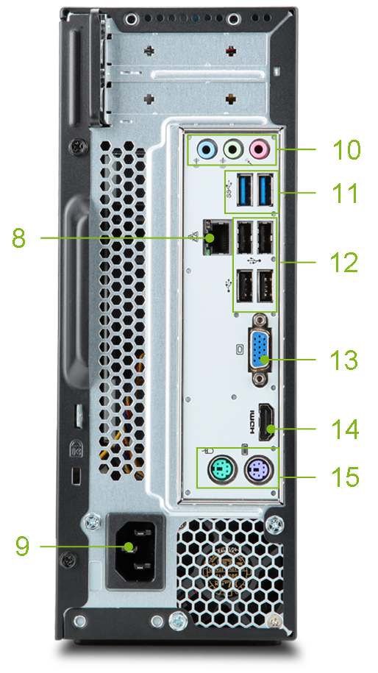
Product views | - Optical disc drive  - ODD eject button  - Three USB 2.0 ports  - Headphone and microphone jacks  - Two USB 2.0 ports |  | - Multi-in-1 card reader  - Power button  - Ethernet (RJ-45) port  - Power connector  - Three audio jacks |  |  | - Two USB 3.0 ports  - Four USB 2.0 ports  - D-Sub VGA port  - HDMI® port  - PS/2 mouse and keyboard port
Operating system¹ | Genuine Windows® 7 Home Premium 64-bit² |  |  |  | Genuine Windows® 7 Home Basic 64-bit²
Operating system¹ | Genuine Windows® 7 Home Premium 32-bit |  |  |  | Genuine Windows® 7 Home Basic 32-bit
Operating system¹ | Linpus® Linux® X Window
Processor¹ | AMD A-Series & E2-Series APU
Chipset | AMD A75 FCH
Memory^{1, 3, 4} | Up to 16 GB of DDR3 1333 MHz SDRAM (dual-channel support on four DIMMs)
Hard drive | Serial ATA hard disk up to 2 TB
Optical drive | BD Combo |  | SuperMulti |  |  | DVD-ROM
Card reader³ | Multi-in-1 card reader
Grahpics¹ | AMD HD Graphics | Discrete card support for high-end NVIDIA® GeForce® and AMD Radeon™ high-end graphics cards³
Audio | Embedded high-definition audio support
Networking | LAN: Gigabit Ethernet |  |  |  | WLAN:^{1, 3, 4} 802.11b/g/n Wi-Fi CERTIFIED™
Software | Acer clear.fi  Acer eRecovery Management  Adobe® Flash® Player  Adobe® Reader®  Bing™ bar  Bing™ setup |  |  |  | McAfee® Internet Security Suite  Microsoft® Word and Excel with advertising; no PowerPoint or Outlook. Buy Office 2010 to use the full-featured software. (except Japan)  Nero® 10 Essentials  WildTangent® GameZone
Dimensions | 100 (W) x 367.8 (D) x 269.5 (H) mm
BIOS | AMI BIOS compatible with SMBIOS 2.4
Power supply | 220 W (PFC/non-PFC/FR)
System compliance | PC 2001,Windows 7 , MDA 2011
Certification | FCC, CE, BSMI, VCCI, CB, MET
Optional accessories | Acer wireless, USB or PS/2 keyboard and mouse
- Specifications vary depending on model.  - 64-bit software is required to enjoy the advantages of 64-bit processing.  - Optional |  |  |  | - Actual throughput may vary depending on network conditions and environmental factors such as network traffic or overhead, building construction and access point settings.  - Bundled software may vary depending on hardware configuration, OS, and regional availability.
© 2011. All rights reserved. Acer Inc. All other trademarks are the property of their respective owners. All specifications are subject to change. Pictures are not contractual.
Microsoft and Windows are registered trademarks of Microsoft Corporation.
Please visit www.acer.com for more information.

